Charts as Pathways to Success
Posted: February 20, 2014 | Author: chartchums | Filed under: Uncategorized | Tags: assessment, charts, goals, independence, mindset, planning, Reading |3 Comments
In the NCTE position paper on Formative Assessment (October 21, 2013) there is a handy list of ten elements that make up formative assessment. Number five on the list reads:
Requires development of plans for attaining the desired goals.
Hallelujah, we say! So often all we think about is what kids need, or what we need, without quite figuring out how to get there. Its like saying, “I need a million dollars” without having any actual plan to save money, increase your income, or play the lottery. Sad to say making a wish or stating a need alone does not get you the million dollars (but if it does, we will leave our contact information in the comments). Carol Dweck, author of Mindset (2007), and all around intellectual crush of Kristi’s and Marjorie both, speaks to this idea as well. She cites research from Peter Gollwitzer that finds just declaring you will change results in no change at all. Knowing how to get what you need is as critical as knowing what you need. More from Mindset:
What works is making a vivid, concrete plan: “Tomorrow during my break, I’ll get a cup of tea, close the door to my office, and call the graduate school.” Or in another case: “On Wednesday morning, right after I get up and brush my teeth, I’ll sit at my desk and start writing my report.” … Think of something you need to do, something you want to learn, or a problem you have to confront. What is it? Now make a concrete plan. When will you follow through on your plan? Where will you do it? How will you do it? Think about it in vivid detail….These concrete plans – plans you can visualize – about when, where, and how you are going to do something lead to really high levels of follow through, which, of course, ups the chance of success (Dweck, p. 228).
This, dear friends, is where charts come in!
Co-creating a personalized or class chart helps children visualize the attainment of whatever goal they have, which in turn will lead to increased follow through and success. We write down recipes and directions for a reason. It is not enough to know you want to make lasagna, you need the steps to be successful. Once your formative assessments have helped you and your students identify areas of need, charts help everyone get there, they provide the steps. We refer to these particular charts as process charts, and have more about them in our upcoming book, Smarter Charts for Math, Science and Social Studies.
Some Tips:
1. Use your goal (or destination) as your heading. This keeps the focus on the big idea, not the ticky tacky bits that make it up.
2. Use numbers or arrows when appropriate, these small reminders help children be organized in their thinking and their work.
3. Co-construct the chart so that the children visualize alongside you, using their language as much as possible to make the chart meaningful and personal.
4. Use visuals that break down the steps quickly and easily.
Some Examples:
Supporting an Individual Child’s Growth in Reading
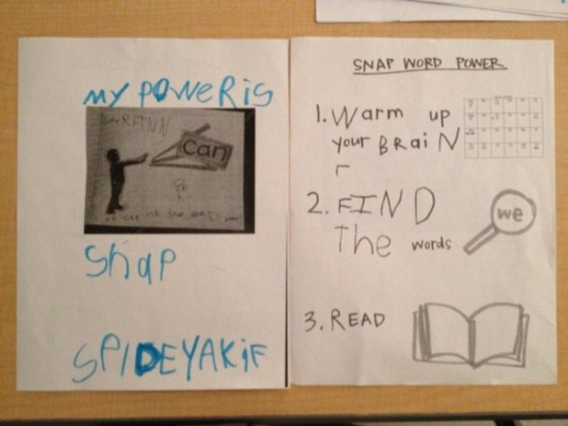
Step 1: The Formative Assessment:
Kristi found that this student had a host of snap words he knew by heart in isolation, but when it came time to reading books, all that knowledge flew out the window. His running records showed many miscues for words that he knew on sight. Usage of these words as he read would help his comprehension and his accuracy. As an English Language Learner, this child was at a disadvantage in relying on his syntax, but sight words could be a strength for him to depend on.
Step 2: The Plan
Kristi sat with this child to explain the conundrum, ending with the reason why snap words matter to readers. It helps us understand and read the book, saving our brain energy for the tricky words. The child and Kristi co-constructed a plan: first warm up to remember all the words he knows, then take a book walk to see if he could find any of those words in the book he wanted to read, then read the book.
The when: Before you read
The where: On the snap word list, and in the books
The how: Warm-up and then go!
Supporting Whole Class Growth in Comparing and Contrasting
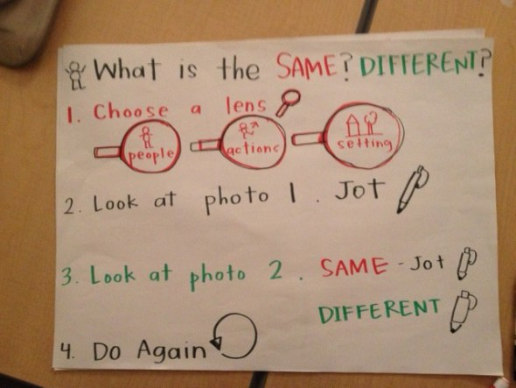
Step 1: The Formative Assessment
Marjorie asked a group of students to compare and contrast two photos of classrooms from long ago and today and found that many children struggled. Some did not know what to write, some just wrote about one photo, some described what they thought was happening.
Step 2: The Plan
Marjorie designed lessons around the lenses children could use to look at photos, emphasizing that when you look between two items, you always want to ask yourself: what is the same? what is different?
The when: Whenever you have two things in front of you, it is a worthy endeavor to figure out out how they are the same and how they are different.
The where: In social studies, science, reading, writing, math – any of these times could work for comparing two things.
The how: Go slowly and systematically, when you try to see everything you see nothing. Choose one lens at a time and repeat the plan as needed.
Just One More Reason To Love Charts!
Charts are not just descriptive: here is how we did something, they can also be prescriptive: here is how to do something. In a classroom you may have charts that represent both ideas, but the important thing is that you have charts. Charts serve as a way to grow independence, but also as models of ways to achieve success. A thoughtful recording of the where, when, and how is a skill that will help children (and teachers!) for a lifetime.

