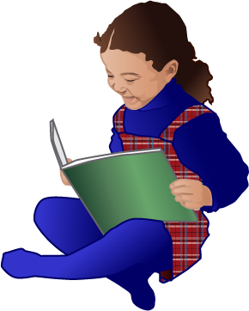
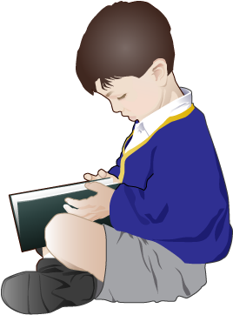
INTERVIEW WITH A READER

NAME
DATE | GRADE
Interviewed by

- Do you like to read?

- Where do you like to read?

- Who reads with you at home?

- What’s your favorite: reading by yourself or having someone read to you?

- Do you have books at home? Tell me about them.

- Tell me about one of your favorite books.

