“Garden Helpers” Kindergarten
(From National Geographic Young Explorers September 2009)
1

2

Not all bugs and worms are pests. Some help your garden grow. Earthworms make soil rich and healthy. This helps plants grow strong!
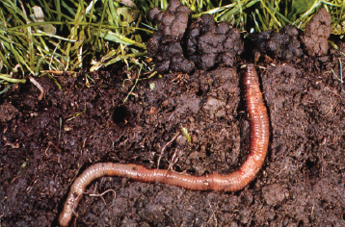
Earthworm
Soil
A ladybug eats small bugs. The bugs can’t eat the plants. This keeps your garden safe.
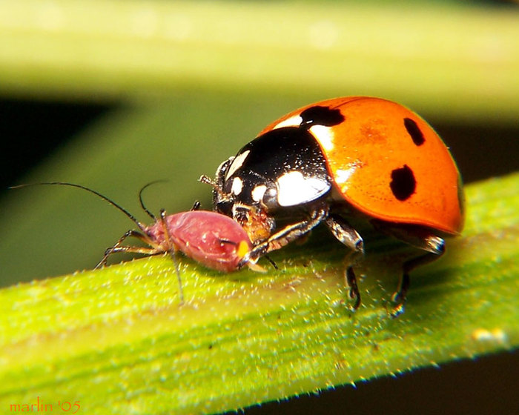
Aphids: A pest that destroys leaves on plants.
Ladybug
A Praying Mantis eats any bug it can catch. Not many bugs can get past this quick hunter!
3

4
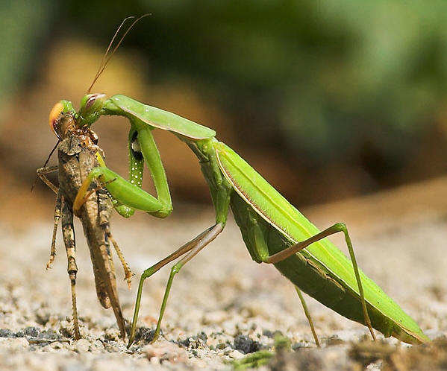
Grasshopper
Praying Mantis
This spider catches bugs in its sticky web. It keeps bugs away from your garden.
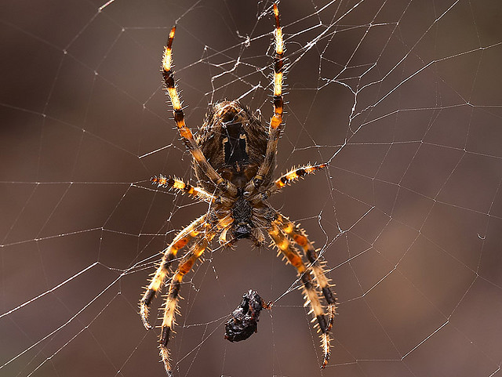
Fly
Sticky Web
Spider

Teacher’s Edition
Background Building:
Talk with students about the difference between helpers and pests. Ask them what helpers do and then what pests do. (Helpers make things easier and better for people and animals and plants. Pests annoy people and animals and keep plants from growing and being healthy.)
Then say something like: “We are going to read about bugs or insects that we sometimes would think of as pests, but in the garden, they are helpers.”
Guided Highlighted Reading for Content/Summary (Close and Critical Reading Question #1)
The goal for the use of this strategy is that students determine what is important in a text and make obvious inferences.
You might use the following prompts to introduce students to Guided Highlighted Reading. Show the selection with illustrations on a screen. Have students talk in partners about how to respond to each prompt. Then have a student point to the words that answer each prompt:
In paragraph #1, find the words that tell what earthworms do to help plants grow. (make soil rich and healthy)
In paragraph #2, find the words that tell what a ladybug does to help plants grow. (eats small bugs)
In paragraph #3, find the words that tell what a praying mantis does to help plants grow. (eats any bug it can catch)
In paragraph #4, find the words that tell what a spider does to keep bugs away from the plants in the garden. (catches bugs in its sticky web)

Follow-up:
Talk with students about the message the author is trying to get across to readers. Ask them what they think the author’s message is for readers. Have students turn and talk with a partner. Then have them share with the class.
Suggested Message: Bugs or insects that we sometimes think of as pests can be helpers in the garden; they can help plants grow.

Author: ________________________

I see a helping in the garden.

Garden Helpers!

By: ________ Kindergarten Class

