STAGES OF EARLY LITERACY

PRE-EMERGENT

- Enjoys listening to and talking about stories.
- Understands that print carries a message and notices environmental print.
- Uses picture cues and predictable patterns in books to retell the story.
- Makes text to self connections.
- Recognizes 5 - 20 familiar or high frequency words.
- Identifies some letters and makes some letter-sound matches.
- Uses known letters or approximations of letters to represent written language.

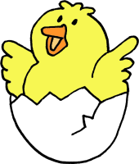
EMERGENT

- Enjoys playing with language and books and wants to read.
- Knows how stories and books work and has one to one correspondence.
- Identifies letter names and sounds fluently and can segment and blend simple words.
- Identifies 20 – 100 sight words.
- Applies knowledge of cueing systems to monitor reading though often relies on one at a time.
- Hears sound sequence in words and is starting to use beginning, middle, and end sounds to decode text.

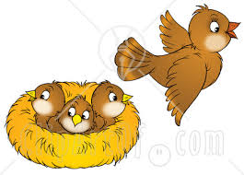
DEVELOPING

- Fluently reads appropriately-leveled text independently.
- Recognizes 100 – 300 high frequency words.
- Figures out unknown words using letter/sound knowledge, analogy, and/or other decoding strategies.
- Integrates cueing systems to monitor and comprehend text.
- Makes self-to-self and text-to-text connections.
- Makes predictions, retells, and recall main ideas and details of narrative and expository text.

FLUENT

- Identifies most words automatically.
- Reads with expression at a rate of 100 words per minute or more.
- Prefers to read silently.
- Uses strategies to identify unfamiliar words.
- Integrates cues and flexibly adapts reading strategies to fulfill a range of purposes.
- Uses knowledge of text structure and genre to support comprehension.
- Makes text-to-self, text-to-world, and text-to-text connections.
- Uses higher level strategies to comprehend text (i.e., inferring, visualizing).

